Sebastian Magri
Professor Koshel
OPTI 306
16 December 2022
Final Project

My element at Blockhead Robot, Inc. is Rhodium. Physical characteristics of Rhodium include the following:
Melt Temperature: $T_{melt}=2236 K$ Sample Temperature: $T_{sample}=T_{melt}*0.75=1677 K$
source https://www.rsc.org/periodic-table/element/45/rhodium

Additionally, Rhodium has a varying emissivity as a function of wavelength. Current experimental emissivity values are limited. However, emissivity values from .7um 5.419um are available from the following source (See Appendix A):
Emissivity: source https://www.sciencedirect.com/science/article/pii/S0021961416302099

Extrapolating the data, we can assume the emissivity for the rest of the optical band and infrared band. Therefore, the emissivity values used for this paper are:
$$ε_{λ}=\left\{ \begin{aligned} 0.32 0.38μm ≤λ <0.7μm \\ Experimental 0.7μm ≤λ ≤5.419μm \\ 0.16 5.419 μm <λ ≤15μm \end{aligned}\right.$$
To determine peak spectral wavelength, peak spectral radiance, and overall radiance, emissivity must be included. Accounting for emissivity, the following Radiance vs. Wavelength graph results:
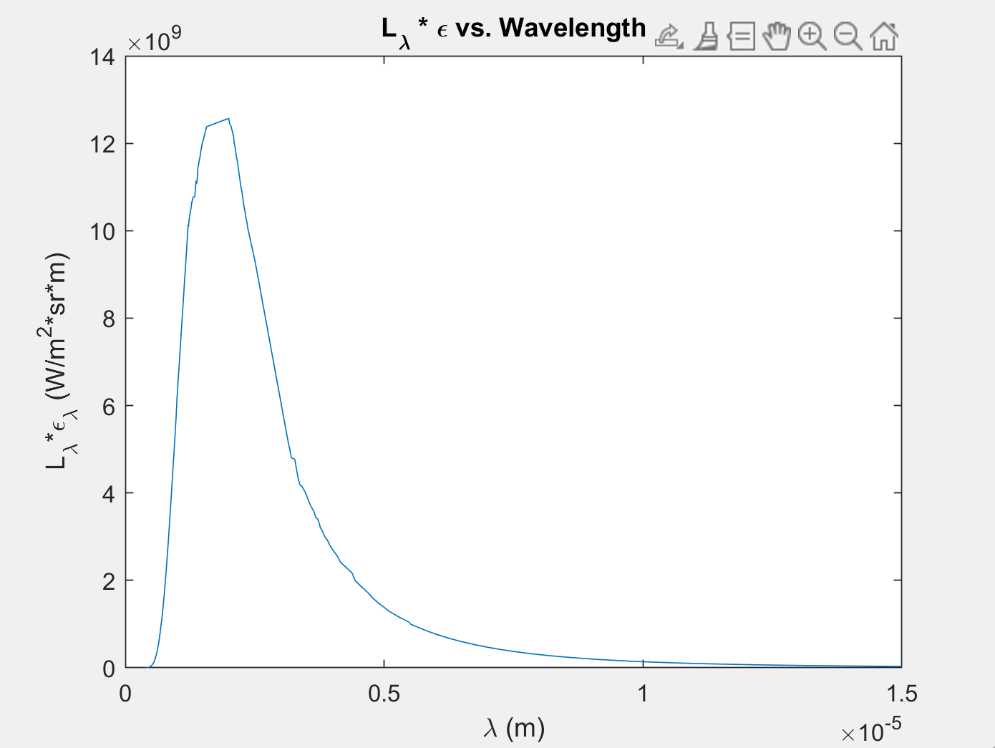

The dimensions of a Blockhead Robot with calculated surface areas of the head, arm, body, and leg are as follows:
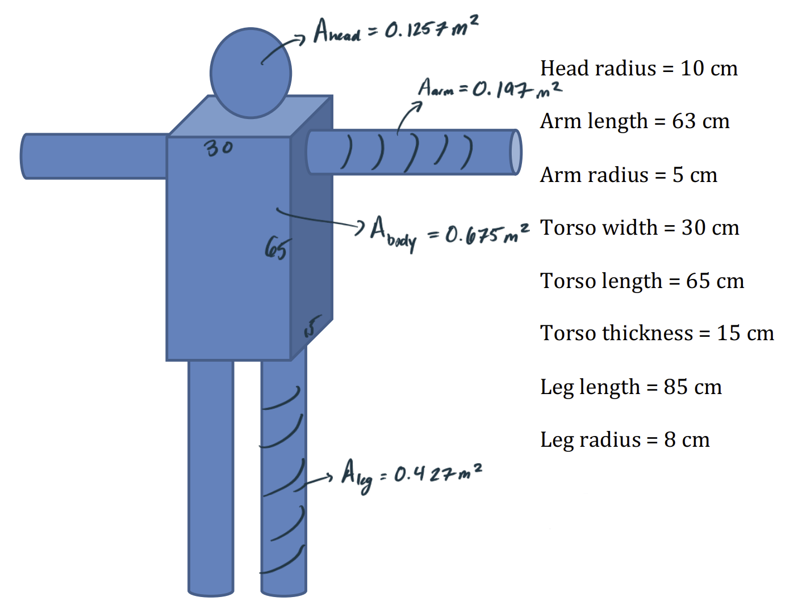
$$Total Area= 2.051017582 m^{2}$$
EXPLAIN CALCULATIONS
T (K) | 1677
lambda peak (m) | 2.00E-06
L_lam_max (w/m^2/sr/m) | 5.31E+10
L (W/m^2/sr) | 3.04E+04
M (W/m^2) | 9.54E+04
Phi (W) | 1.96E+05
lambda min LWIR (um) | 8
lambda max LWIR (um) | 15
LWIR Ltotal (W/m^2/sr) | 7.70E+02
Phi LWIR (W) | 4.96E+03

As suggested in Exam 2, the best spectral band to work in would be the SWIR band (1.8um 3um). However, due to rarity of rhodium and its applications, spectral emissions are only available in optical band (0.38um 0.78um). The availability of spectral emission line data is imperative to choose the correct detector. For this reason, analysis in the optical region will have to be used. The five strongest spectral lines in the optical band according to NIST (Appendix B) are as follows:
Optical Spectral Emission
Wavelength (nm) | Rel Int
385.652 | 5900
395.886 | 3800
413.527 | 2100
421.114 | 3300
437.48 | 4200

b.
c.) https://physics.nist.gov/cgi-bin/ASD/lines1.pl?spectra=Rh&limits_type=0&low_w=380&upp_w=780&unit=1&submit=Retrieve+Data&de=0&I_scale_type=1&format=0&line_out=0&en_unit=0&output=0&bibrefs=1&page_size=15&show_obs_wl=1&show_calc_wl=1&unc_out=1&order_out=0&max_low_enrg=&show_av=2&max_upp_enrg=&tsb_value=0&min_str=&A_out=0&intens_out=on&max_str=&allowed_out=1&forbid_out=1&min_accur=&min_intens=&conf_out=on&term_out=on&enrg_out=on&J_out=on

d.)
Due to broadening, we can assume the spectral bands are 5nm in thickness. The following spectral emission wavelength ranges occur:
Optical Emission Spectra
Δλ Wavelength (nm)
382.5 - 387.5
392.5 - 397.5
410.5 - 415.5
418.5 - 423.5
434.5 - 439.5
e.)
Using these small bands of line emission, we can calculate the total power emitted from each band. To do this we first need to calculate the total radiance in each band.
$$L_{total}=\int_{Δλ}{L_{λ}*ε_{λ} dλ}$$
Using the emissivity described above, the total radiance in each line emission band was calculated using numerical integration in MATLAB. The following radiances for the line emissions were calculated.
Emission Line (nm) | Radiance (W/m^2/sr)
385.652 | 0.004834059
395.886 | 0.007443805
413.527 | 0.014963962
421.114 | 0.020231836
437.48 | 0.035580195

To find the total power emitted from the emission lines, we calculate the product of the radiance, the total surface area of the emission area (ie the surface area of the robot), and the projected solid angle.
$$Φ_{total}=L_{Δλ}*Area*Ω$$
$$Φ_{total}=L_{Δλ}*Area_{robot}*π$$
Emission Line (nm) | Power (W)
385.652 | 0.03114808
395.886 | 0.04796387
413.527 | 0.09641972
421.114 | 0.13036306
437.48 | 0.22925963
Total Power from 5 Emission Lines | 0.53515436

f.)
We see that the total power emitted from 5 Emission Lines is 0.53515436 W. In comparison the total power in the LWIR band is emitted 4,963 W, and the total power emitted across all wavelengths is $1.96*{10}^{5} W$. This power emitted from the spectral lines represents for 0.01 % of the LWIR and 0.0003% of the total power.

g.)
Considering the proposed Oven + Radiometer system from Exam 2 as described in Appendix C, we can calculate the power incident on the detector. To calculate the power incident on the detector, the following equation can be used:
$$Φ_{det Δλ}=\left(3.351257E-7\right)* L_{total Δλ}*α_{det}$$
Note: The constant “3.351257E-7” is a specific value that considers the geometry of the proposed system. This derivation of this value can be seen in Appendix C/Exam 2
Utilizing the above equation, the power on the detector is calculated for the spectral lines:
Emission Line (nm) | Power Incident on Detector (W)
385.652 | 1.62E-09
395.886 | 2.4946E-09
413.527 | 5.0148E-09
421.114 | 6.7802E-09
437.48 | 1.1924E-08
Total Power Incident on Detector from 5 Emission Lines (W) | 2.78336E-08  Or  ~ 27.8 nW

- Total Signal Response

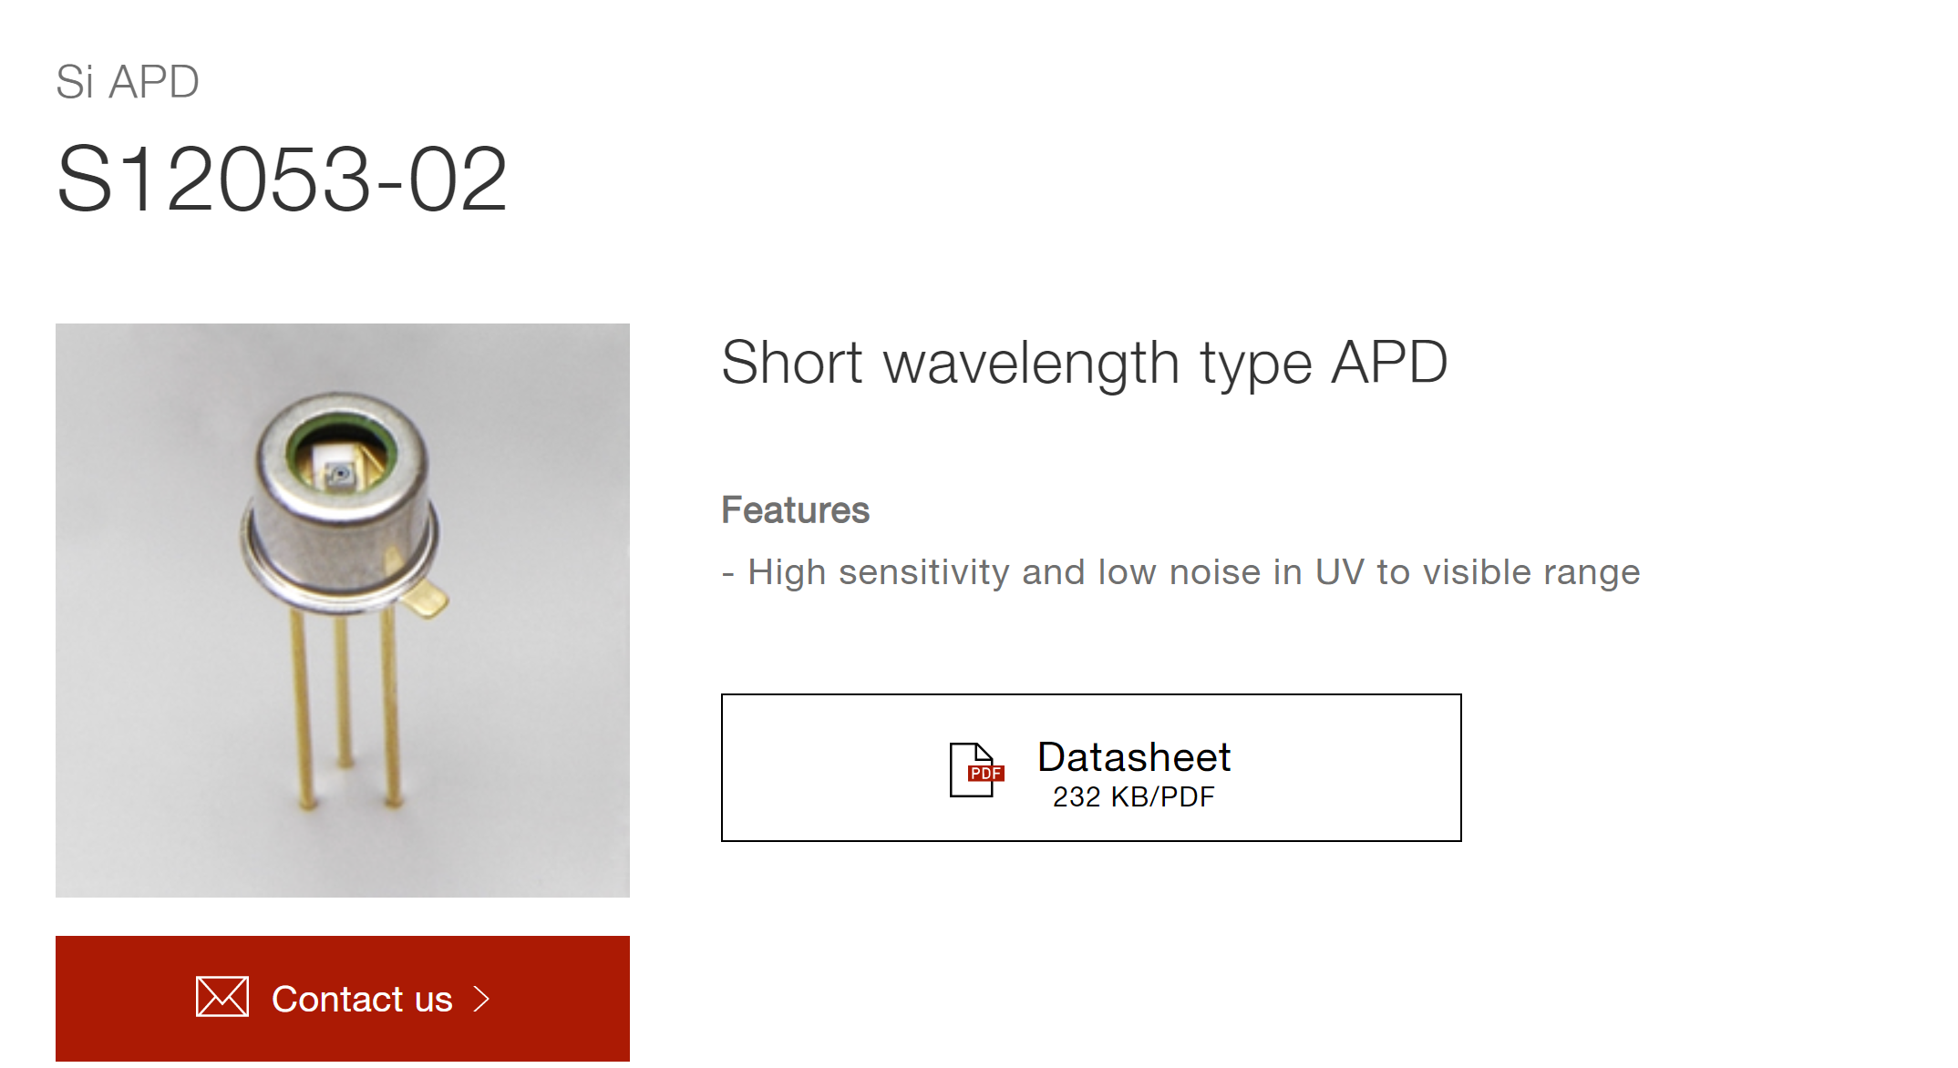
https://www.hamamatsu.com/us/en/product/optical-sensors/apd/si-apd/S12053-02.html
When the system detector, one must take into account several factors. Because we are working in the optical domain, we need a detector that only sees in the optical domain. The signal produced in the optical domain is small. With the given setup, the total power in the optical band that reaches the detector is, in theory, 362 μW. However, our spectral lines account for only about 27nW. With noise likely to be on the nanowatt scale, the best solution is to choose a detector with gain. The detector does not necessarily need to be “fast”
To determine the theoretical signal response, must consider the responsivity of the detector. This can be found in the datasheet.

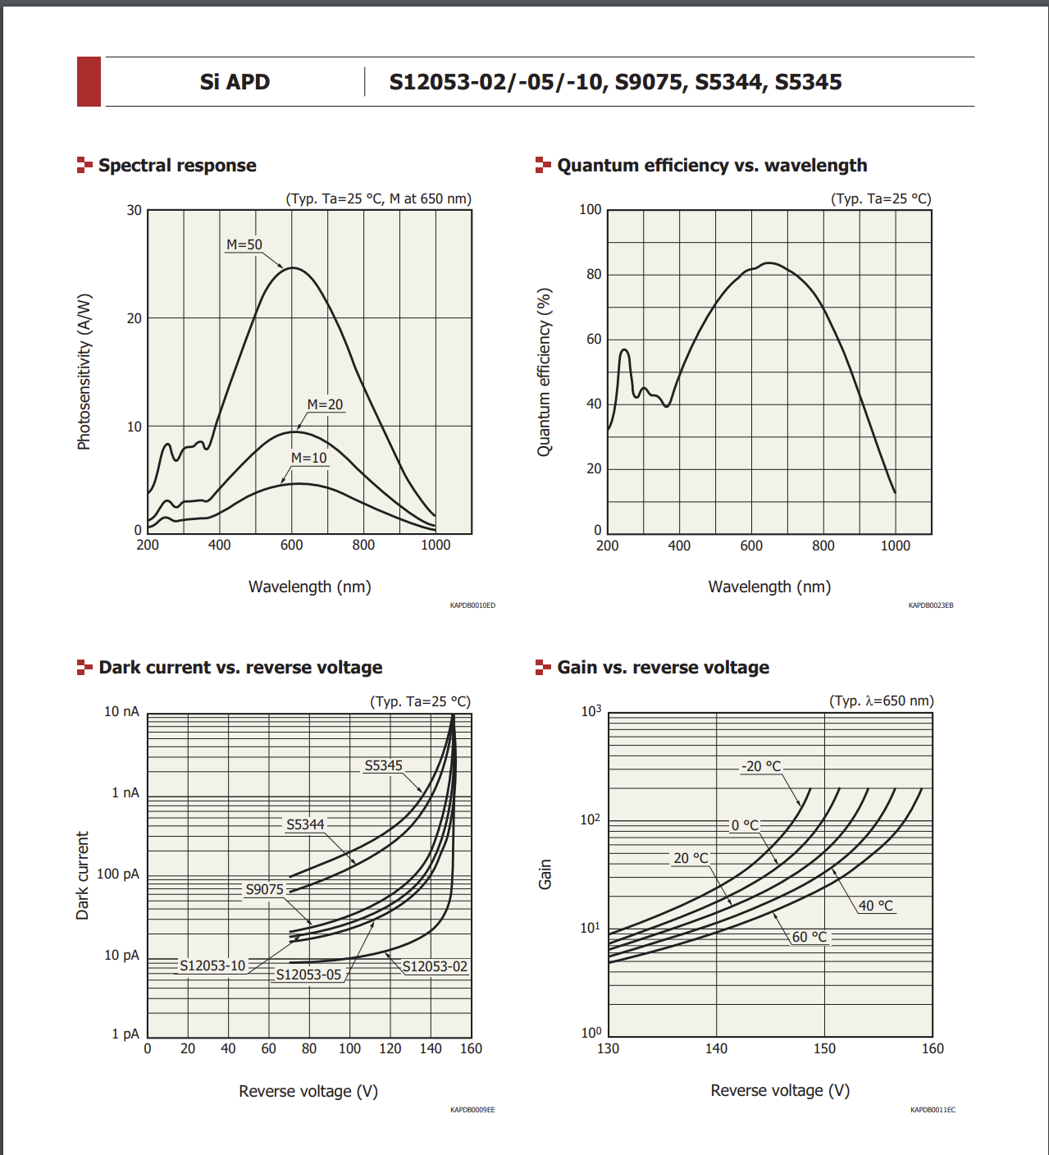
$$\frac{I_{signal}}{{Φ(λ)}_{det emission}}=R(λ)$$
$$I_{signal}=R\left(λ\right)*{Φ(λ)}_{det emission}$$
$$I_{signal}=\int{R\left(λ\right)*L\left(λ\right)*5.46823E-10 dλ}$$
We have 5 different emission bands, that account for signal:
$$I_{spectral line signal}=I_{385nm}+I_{395nm}+I_{413nm}+I_{421nm}+I_{437nm}$$
$$I_{spectral line signal}=5.5498E-10 A=0.55498 nA$$

Types of Noise to Consider
Johnson Noise (Quantum adjusted)
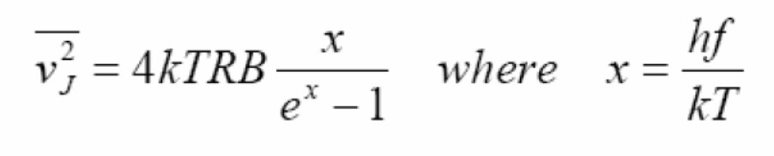
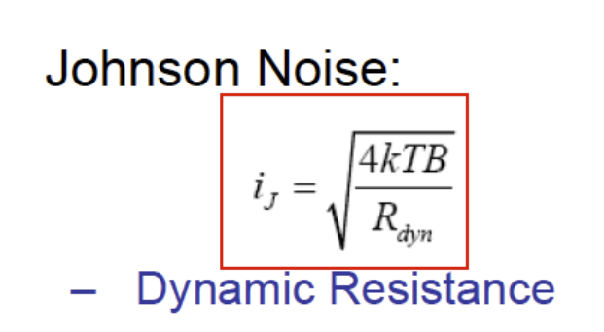
1/f noise
Johnson Noise
$$i_{j}=\sqrt{\int{\frac{4*k_{B}*T*\left(\frac{x}{e^{x}-1}\right)df}{R}}} where x=\frac{hf}{k_{B}T}$$

Shot Noise
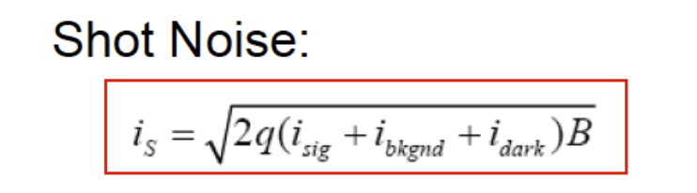
$$i_{s}= \sqrt{2*q*\left(i_{signal}+i_{bkgnd}+i_{dark}\right)*B}$$

Appendix A
Rhodium emissivity values

Appendix B

